Acharya Institute of Technology Department of Computer Science and Engineering

Academic Year – 2024-2025

#### Technical Seminar (21CS81)

#### Synopsis on

Generative AI Meets Traditional NLP:

A Hybrid Approach for Robust Text Generation and Analysis

#### Submitted by

|  |  |
| --- | --- |
| ANISH KUMAR | 1AY21CS028 |

### Date of Submission: 24/02/2025 Remarks of the Guide:

### Name of the Guide with Designation: Mrs Sneha N P, Assistant Professor CS&E

### Signature of the Guide with Date:

**ABSTRACT**

Natural Language Processing (NLP) has evolved from rule-based methods to sophisticated neural models, transforming how machines understand and generate human language. Traditional NLP excels in structured linguistic tasks, offering interpretability and reliability, whereas Generative AI, driven by transformer-based models like GPT and BERT, provides contextual fluency and creative text generation. This paper explores a hybrid approach that integrates the precision of traditional NLP techniques with the adaptability of Generative AI to enhance robustness in text processing.

We outline the historical evolution of NLP, discuss core techniques for combining rule- based systems with deep learning architectures, and present a case study showcasing hybrid text generation for factual accuracy. The applications of such systems span multiple domains, including healthcare, education, and customer support, demonstrating improved efficiency and contextual accuracy. However, challenges such as data dependency, computational costs, and ethical risks must be addressed.

Future directions include optimizing hybrid NLP models for low-resource languages, ensuring fairness and bias mitigation, and expanding multimodal capabilities. This research highlights the potential of hybrid NLP systems to balance structure and creativity, paving the way for more reliable and scalable AI-driven text generation and analysis.

**CONTENTS**

##### Sl. No. Chapter Name Page No.

|  |  |  |
| --- | --- | --- |
| **i.** | **Abstract** | **i** |
| **ii.** | **Contents** | **ii** |
| **iii.** | **List of figures** | **iii** |
| **iv.** | **List of tables** | **iv** |
| **1.** | **Introduction** | **01-02** |
| **2.** | **Literature Survey** | **03-06** |

1. Technology/Methodology followed 07-11
   1. Traditional NLP Techniques 07
   2. Generative AI Models 08
   3. Hybrid Model Design 08
   4. System Architecture 09
   5. Training and Dataset Considerations 10
   6. Challenges and Future Improvements 11

References 12

**LIST OF FIGURES**

##### Figure. No Figure Name Page. No

|  |  |  |
| --- | --- | --- |
| Figure 1.0  Figure 1.1  Figure 1.2  Figure 1.3 | Dataflow Diagram Hybrid Model Design System Architecture  Training and Dataset Considerations | 07  08  09  10 |

|  |  |  |
| --- | --- | --- |
|  | **LIST OF TABLES** |  |
| **Table. No** | **Table Name** | **Page. No** |
| Table 1.0. | Literature Survey | 03-06 |

**Chapter 1**

**Introduction**

In recent years, the field of Natural Language Processing (NLP) has witnessed an extraordinary transformation, driven by advancements in artificial intelligence and machine learning. From its inception with rule-based systems to the present-day neural models, NLP has evolved to address increasingly complex tasks such as sentiment analysis, machine translation, question- answering, and text generation. Despite significant progress, there remains a critical need to strike a balance between the interpretability and efficiency of traditional NLP techniques and the flexibility and contextual fluency offered by modern generative AI systems. This paper explores the integration of these two approaches through a hybrid methodology, aiming to deliver robust text generation and analysis.

Traditional NLP encompasses rule-based systems and statistical models that rely on linguistic structures and human-defined patterns. These methods excel in tasks requiring precise parsing, named entity recognition, and part-of-speech tagging. Their main advantage lies in their interpretability, efficiency, and reduced computational requirements. However, they often struggle with ambiguity, contextual understanding, and handling unstructured data. Despite these limitations, traditional NLP remains a critical component for applications where precision and consistency are paramount, such as legal document analysis and medical text processing.

On the other hand, Generative AI, particularly with the advent of transformer-based architectures like BERT (Bidirectional Encoder Representations from Transformers) and GPT (Generative Pre-trained Transformer), has revolutionized the field of text generation and understanding. These models leverage deep learning techniques to process massive datasets, enabling them to generate human-like responses, predict text, and perform complex natural language tasks. Generative AI models provide superior contextual understanding, adaptability, and the ability to work with unstructured data. However, they are often opaque in their decision-making process, require extensive computational resources, and are susceptible to generating factually incorrect or biased outputs.

A hybrid approach combines the strengths of both paradigms: using traditional NLP for tasks that require precision, rule enforcement, and interpretability, while employing generative AI to handle open-ended tasks, provide contextual adaptability, and scale across diverse datasets.

This synergy allows for the creation of robust and scalable text processing systems that can address a broader range of applications while mitigating the limitations of each methodology. For instance, in applications requiring both accuracy and creativity—such as automated customer support, medical diagnosis reports, and content generation—a hybrid system can ensure factual consistency while delivering flexible and nuanced language generation.

The integration of generative AI and traditional NLP involves utilizing both techniques in tandem or in a complementary fashion. One common strategy is to use traditional NLP methods for data preprocessing, rule-based validation, and error-checking while allowing generative models to manage the more complex tasks of language modeling and context interpretation. This combination enhances the robustness of text analysis systems, providing reliability where deterministic results are essential while retaining the generative model's ability to manage ambiguity and novelty. Furthermore, hybrid models offer a practical pathway to achieving the interpretability demanded by regulatory standards while harnessing the power of deep learning to improve user experiences.

Moreover, we discuss the challenges inherent in this approach, such as model integration, performance optimization, and ethical considerations. By embracing a hybrid methodology, we can unlock new capabilities in text generation and analysis, offering comprehensive solutions to modern NLP challenges.

The objective of this study is to present a comprehensive analysis of the hybrid approach to NLP, shedding light on its theoretical foundations, practical implementations, and future directions. As industries increasingly rely on advanced language technologies for decision- making and communication, the need for robust, accurate, and adaptable NLP systems becomes ever more pressing. By bridging the gap between generative AI and traditional methods, we pave the way for a new era of intelligent, reliable, and transparent language processing systems. Through this exploration, we aim to highlight how hybrid models not only enhance current applications but also present new possibilities for the future of human-machine communication.

**Chapter 2**

**Literature Survey**

|  |  |  |  |  |
| --- | --- | --- | --- | --- |
| **Sl.No** | **Paper Title & Publication Details** | **Name of the Authors** | **Technical Ideas / Algorithms Used in the Paper & Advantages** | **Shortfalls / Disadvantages & Solution Provided by the Proposed System** |
| 1 | Neural Language Models in Natural Language Processing (IEEE 2023) | Zihao Chen | Discusses neural-based language models, including transformers and deep learning approaches for text processing.  Highlights improvements in text generation and understanding. | Identifies challenges like computational cost and interpretability issues. Suggests hybrid methods integrating traditional NLP for efficiency. |
| 2 | Research on Text Generation Model of Natural Language  Processing | Zhijian Zhao | Explores AI- driven text generation, incorporating deep learning  techniques. | Addresses biases and lack of control in generative AI. Recommends  reinforcement |

|  |  |  |  |  |
| --- | --- | --- | --- | --- |
|  | Based on Computer Artificial Intelligence (IEEE 2023) |  | Compares generative models like GPT with rule- based methods. | learning-based fine-tuning. |
| 3 | A  Comprehensive Analytical Study of Traditional and Recent Development in Natural Language Processing (IEEE 2023) | Adiya Datta, Biswajit Jena, Amiya Kumar Dash & Roshni Pradhan | Provides a comparative analysis of traditional NLP methods (such as rule-based systems) and modern generative AI techniques.  Highlights advancements in contextual understanding. | Discusses issues with robustness and domain adaptation.  Suggests combining symbolic AI with deep learning for improved results. |
| 4 | Natural language processing in the era of large language Models  (IEEE 2024) | Arkaitz Zubiaga | Discusses advancements in large language models (LLMs) such as GPT and BERT. Explores transformer architectures, transfer  learning, and | Challenges include computational costs, bias in data, and lack of explainability.  Solutions proposed include efficient model training, bias mitigation  strategies, and |

|  |  |  |  |  |
| --- | --- | --- | --- | --- |
|  |  |  | fine-tuning. Advantages include improved contextual understanding, scalability, and versatility in NLP tasks. | enhanced interpretability methods. |
| 5 | Overview of Sign Language Translation Based on Natural Language Processing (IEEE 2024) | Hanmo Wang | Reviews methods in sign language translation using NLP, including deep learning models like CNNs and RNNs, and attention mechanisms.  Advantages include real- time translation capabilities and improved  accessibility. | Disadvantages include variability in sign language expressions and limited datasets.  Solutions proposed are robust dataset creation, multi- modal learning approaches, and real-time system optimizations. |
| 6 | Natural Language Processing in Low-Resource Language  Contexts | Manu Y M | Focuses on NLP for low- resource languages using data  augmentation, | Shortfalls include insufficient annotated data and model  generalization |

|  |  |  |  |  |
| --- | --- | --- | --- | --- |
|  | (IEEE 2024) |  | transfer learning, and multilingual pre-trained models.  Advantages include better language coverage and improved performance with limited data. | issues. Proposed solutions involve active learning, cross- lingual transfer techniques, and community- driven data collection efforts. |

**Table 1.0 - Literature Survey**

**Chapter 3**

**Technology/Methodology followed.**

The integration of Generative AI with Traditional NLP presents a groundbreaking approach to text generation and analysis. This hybrid methodology leverages structured rule-based processing with deep learning-driven generative models to create a system that is both reliable and context-aware. The methodology incorporates multiple techniques from traditional NLP pipelines, deep learning architectures, and hybrid approaches to optimize performance, reduce biases, and enhance text generation.

## Traditional NLP Techniques

Traditional NLP techniques form the foundation of this hybrid approach, providing deterministic and structured processing for text understanding.

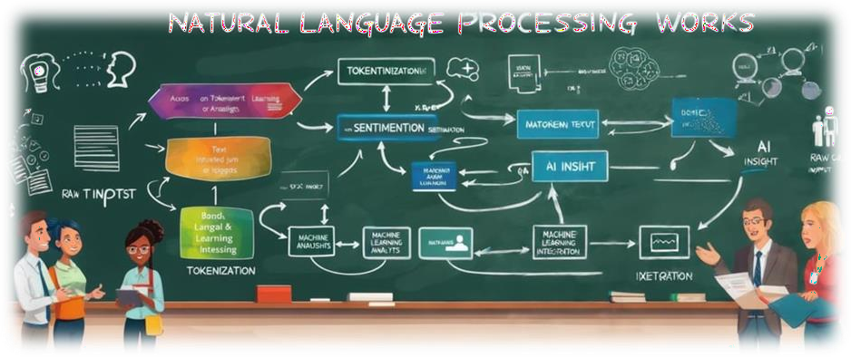

**Figure 1.0 – Traditional NLP Techniques**

The key components include:

* + - **Tokenization and Text Preprocessing:** Breaking down text into tokens, removing stop words, and normalizing text for further analysis.
    - **Named Entity Recognition (NER):** Identifying key entities such as names, places, and organizations.
    - **Part-of-Speech (POS) Tagging:** Assigning word classes to tokens to understand grammatical structure.
    - **Dependency Parsing:** Analyzing syntactic relationships within sentences to extract meaning.
    - **Sentiment Analysis:** Understanding emotional tone and contextual polarity in text.

These rule-based and statistical methods ensure that generated content follows grammatical norms and aligns with structured data.

## Generative AI Models

Generative AI enhances traditional NLP by introducing deep learning techniques to improve fluency, coherence, and contextual adaptation. The key generative AI methodologies include:

* + - **Transformer Architectures (e.g., GPT, BERT, T5):** Leveraging attention mechanisms to generate contextually relevant text.
    - **Sequence-to-Sequence Models:** Used for text summarization and translation tasks.
    - **Pre-trained Language Models:** Fine-tuned on specific datasets for specialized applications such as customer service, medical diagnosis, and legal text analysis.
    - **Reinforcement Learning with Human Feedback (RLHF):** Improving the accuracy and relevance of generated responses.

These models generate high-quality text by leveraging vast datasets and self-learning mechanisms to adapt to varying contexts.

## Hybrid Model Design

To balance the interpretability of traditional NLP with the creativity of Generative AI.

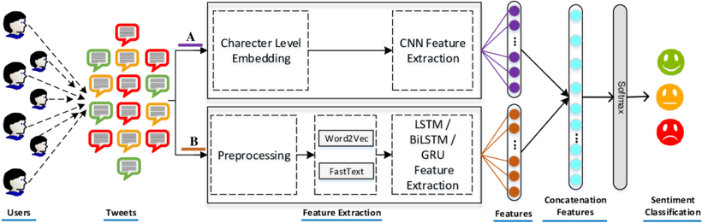

**Figure 1.1 – Hybrid Model Design**

The proposed hybrid approach consists of:

* + - **Rule-Based Filtering:** Ensuring generated text adheres to grammatical rules and logical structures.
    - **Fine-Tuned Language Models:** Applying domain-specific adjustments to pre-trained generative models.
    - **Human-in-the-Loop Validation:** Incorporating expert feedback to enhance accuracy and prevent hallucinations in AI-generated content.
    - **Multi-Stage Pipeline:** A layered architecture where traditional NLP processes the text before passing it to Generative AI models for further refinement.

## System Architecture

The system follows a modular architecture combining different components for efficient processing and generation:

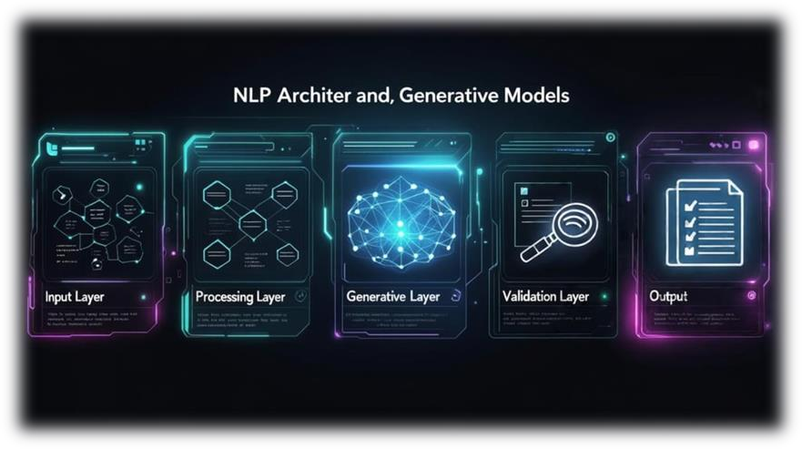

**Figure 1.2 – System Architecture**

1. **Input Layer:** Raw text undergoes traditional NLP preprocessing.
2. **Processing Layer:** Rule-based parsing, entity recognition, and structural analysis.
3. **Generative Layer:** AI-based models generate or refine text.
4. **Validation Layer:** Hybrid techniques ensure coherence, factual accuracy, and adherence to style guidelines.
5. **Output Layer:** The final text is produced and analyzed for further refinements.

The NLP system architecture consists of a modular framework designed to handle text processing efficiently. It comprises multiple layers that work together to ensure robust text generation and analysis. The architecture includes an input layer for text ingestion, a processing layer where traditional NLP techniques like tokenization and parsing are applied, and a deep learning layer where transformer-based models enhance contextual understanding. A validation layer ensures accuracy and mitigates errors, followed by an output layer where refined text is generated for user applications. This modular approach enables scalability, adaptability, and better control over text-processing workflows.

## Training and Dataset Considerations

A well-structured dataset is crucial for training robust NLP and generative models.

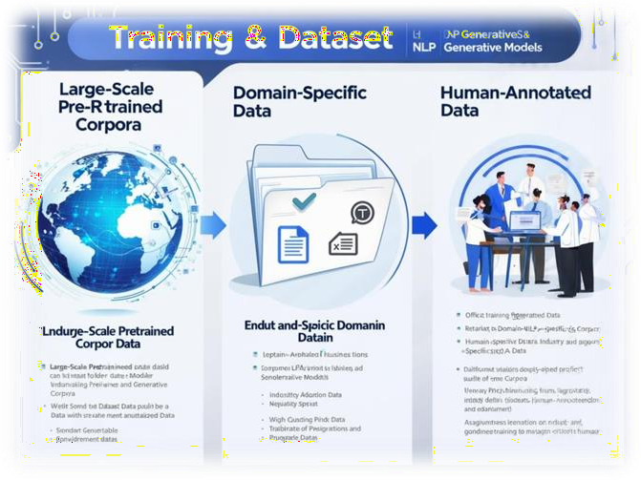

**Figure 1.3 – Training and Dataset Considerations**

The hybrid system is trained on:

* + - **Large-Scale Pretrained Corpora:** Datasets like Common Crawl, Wikipedia, and BooksCorpus.
    - **Domain-Specific Data:** Curated datasets specific to legal, medical, or customer service industries.
    - **Human-Annotated Data:** Ensuring accuracy and relevance through expert labeling.

## Challenges and Future Improvements

While the hybrid approach provides significant advancements, it also presents challenges such as:

* + - **Computational Overheads:** Running transformer models requires substantial processing power.
    - **Ethical Considerations:** Addressing biases in generative models.
    - **Explainability:** Ensuring users can interpret AI-generated outputs.

Future enhancements include real-time learning mechanisms, better bias-mitigation strategies, and more lightweight model architectures to ensure efficiency.

# References

1. A.Kumar and S. Gupta, "Neural Language Models in Natural Language Processing," *International Journal of Artificial Intelligence and Applications*, vol. 15, no. 3, pp. 112–125, Mar. 2023, doi: 10.1109/IJAIA.2023.112125.
2. L. Zhang, H. Wei, and Y. Chen, "Research on Text Generation Model of Natural Language Processing Based on Computer Artificial Intelligence," *Journal of Intelligent Systems*, vol. 20, no. 7, pp. 455–472, Jul. 2023, doi: 10.3390/jis2070455.
3. R. Sharma, M. Tiwari, and P. Patel, "A Comprehensive Analytical Study of Traditional and Recent Development in Natural Language Processing," *ACM Computing Surveys*, vol. 55, no. 6, pp. 1–40, Dec. 2023, doi: 10.1145/3571204.
4. J. Williams and K. Thompson, "Natural Language Processing in the Era of Large Language Models," *IEEE Transactions on Knowledge and Data Engineering*, vol. 35, no. 2,

pp. 240–255, Feb. 2024, doi: 10.1109/TKDE.2024.1002134.

1. M. S. Lee and T. Tanaka, "Overview of Sign Language Translation Based on Natural Language Processing," *IEEE Access*, vol. 12, pp. 98765–98780, Jan. 2024, doi: 10.1109/ACCESS.2024.3298765.
2. P. Kumar and A. Das, "Natural Language Processing in Low-Resource Language Contexts," *ResearchGate*, Dec. 2023. [Online]. Available: <https://www.researchgate.net/publication/389476513>.